SRM IST,RAMAPURAM,
DEPARTMENT OF MATHEMATICS
21MAB206T/2T – NUMERICAL METHODS ANALYSIS
MODULE-II – FINITE DIFFERENCES AND INTERPOLATION
MULTIPLE CHOICE QUESTIONS
- The independent variable x, in the function y = f(x) is called as
- variable (b) entry (c) argument (d) constant
- The dependent value y, in the function y = f(x) is called as
(a) argument (b) entry (c) variable (d) constant
- The nth forward differences of y are denoted by
(a) (b) (c) (d)
- The central difference operator is defined by
(a) (b)
(c) (d)
- The translation operator E is defined by
(a) Ef(x) = f(x+h) (b) Ef(x) = f(x) (c) Ef(x+h) = f(x) (d) Ef(x) = f(x-h)
- The unit operator 1 is defined by
(a) 1.f(x) = f(x) (b) 1+f(x) = f(x)
(c) 1-f(x) = f(x) (d) f(x) = 1.f(x+h)
- The relation between E and is
(a) (b)
(c) (d)
- The relation between E and is
(a) (b) (c) (d)
- Relation between D and is
(a) (b) (c) (d)
- The relation between E and is
(a) (b) (c) (d)
- If the nth differences of a tabulated function are constants, then the function is a polynomial of degree
(a) One (b) Two (c) n - 1 (d) n
- Newton’s forward interpolation formula can be used for interpolating
(a) Unequal intervals (b) Outside the interval
(c) A value of y nearer to the end of the table of values
(d) A value of y nearer to the beginning of the table of values
- Central difference interpolation formulae is used to interpolate
(a) beginning values of the table (b) end values of the table
(c) Central value of the table
(d) Outside the difference table
(a) (b)
(c) (d)
(a) (b) (c) (d) 1
(a) (b) (c) (d) E
(a) (b) (c) (d)
(a) (b) (c) (d) E
- The (n+1)th and higher differences of a polynomial of degree ‘n’ are
- quadratic (b) Parabolic (c) Linear (d) Zeros
- (b) (c)
(d)
- When the values of the independent variable x are equally spaced then to find the value of y,
(a) Newton’s divided difference interpolation formula is used
(b) Newton’s forward and backward formula is used
(c) Operators are used
(d) Average operator is used
- The nth difference (forward) of a polynomial of nth degree are
(a) argument (b) entry (c) variable (d) constants
- The first two terms in the Newton-Gregory forward interpolation formula will give
(a) Linear interpolation (b) Parabolic interpolation
(c) Quadratic interpolation (d) Hyperbolic interpolation
- The first three terms in the Newton-Gregory forward interpolation formula will give
(a) Linear interpolation (b) Parabolic interpolation
(c) Quadratic interpolation (d) Hyperbolic interpolation
- When the values of the independent variables are not equally spaced, then we apply
(a) Central difference interpolation formula
(b) Newton’s forward formula
(c) Newton’s backward formula
(d) Lagrange’s interpolation formula
- Interpolation is the process of
(a) finding the values outside the interval
(b) finding the values inside the interval
(c) finding the values of the constant
(d) finding the values of the variables
- Extrapolation is the process of
(a) finding the values outside the interval
(b) finding the values inside the interval
(c) finding the values of the constant
(d) finding the values of the variables
- The principle of method of least squares states that the best fitting curve to the set of points is that for which the sum of squares of residual is

(a) Minimum
(b) Maximum
(c) Greater than zero
(d) Less than zero
- If the sum of squares of residual is zero, then the given set of points lie
(a) below the actual curve
(b) above the actual curve
(c) on the actual curve
(d) near the actual curve
- One of the normal equations to fit a straight line 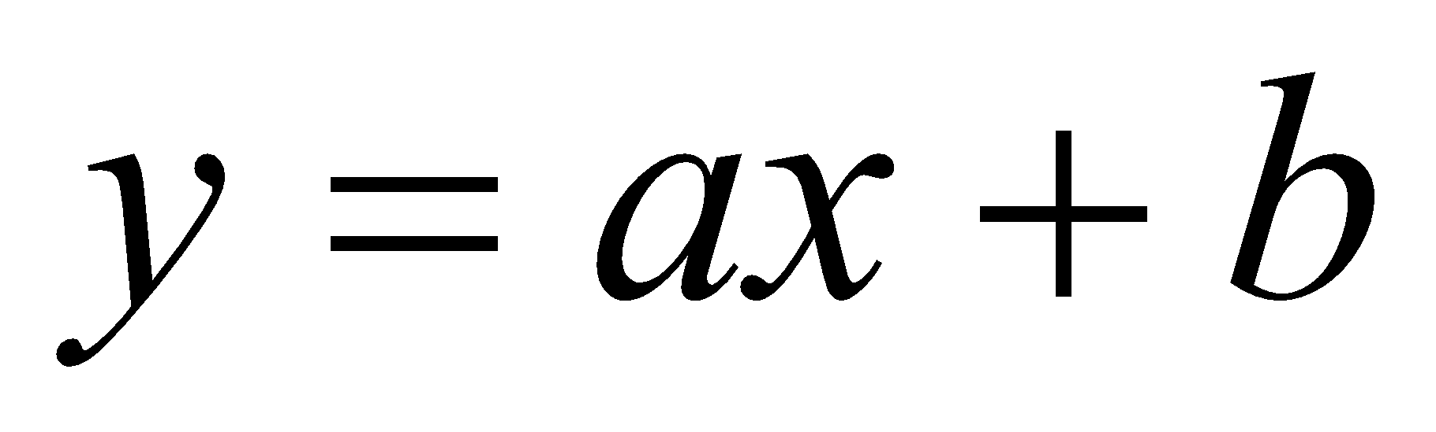 is
(a) 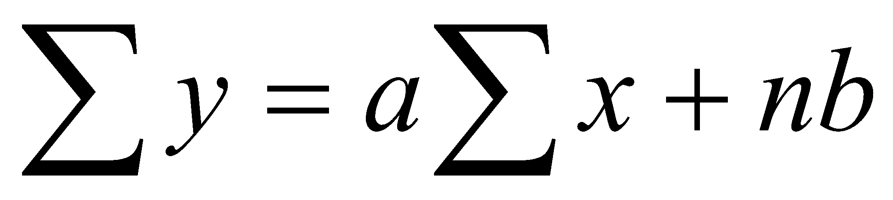 (b) 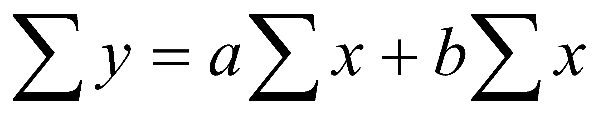 (c) 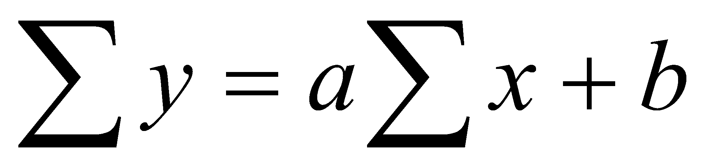 (d) 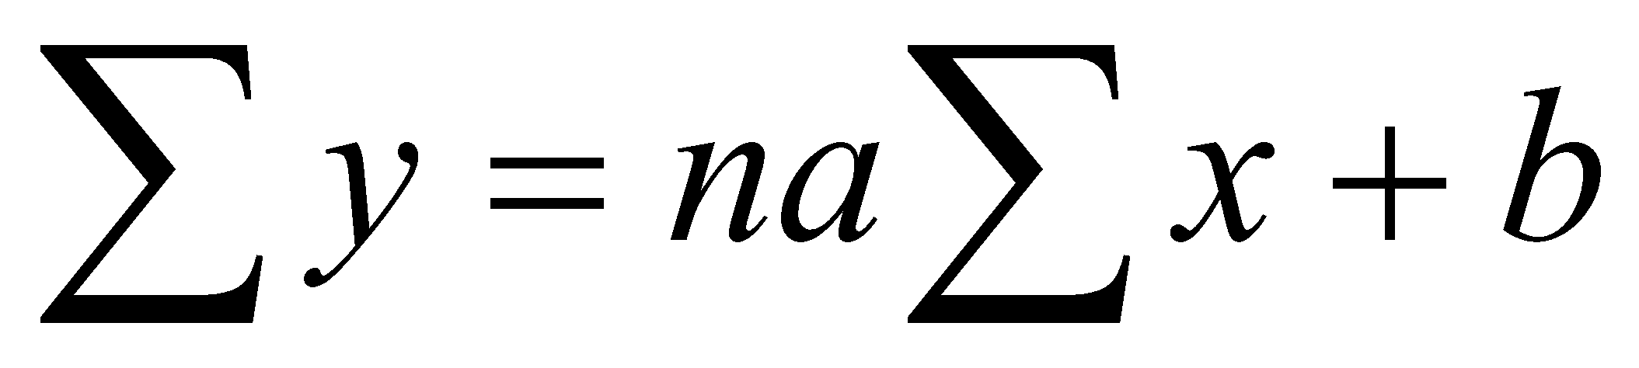
- One of the normal equations to fit a parabola 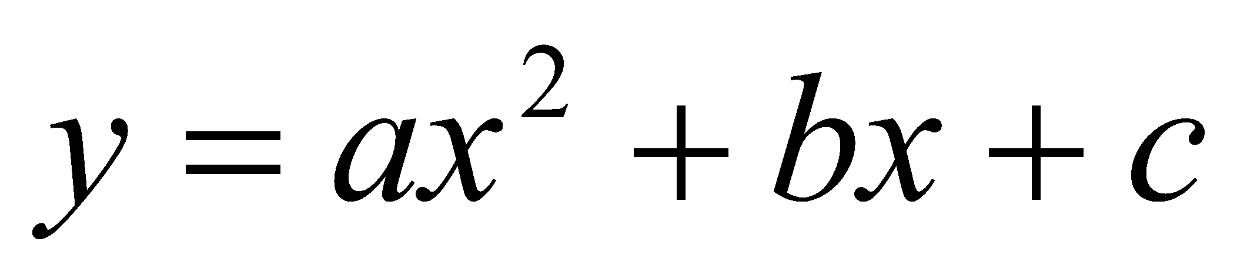 is
(a) 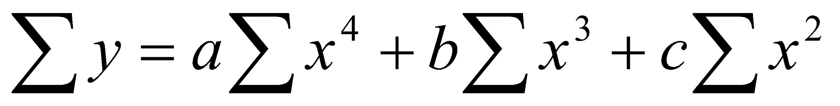 (b) 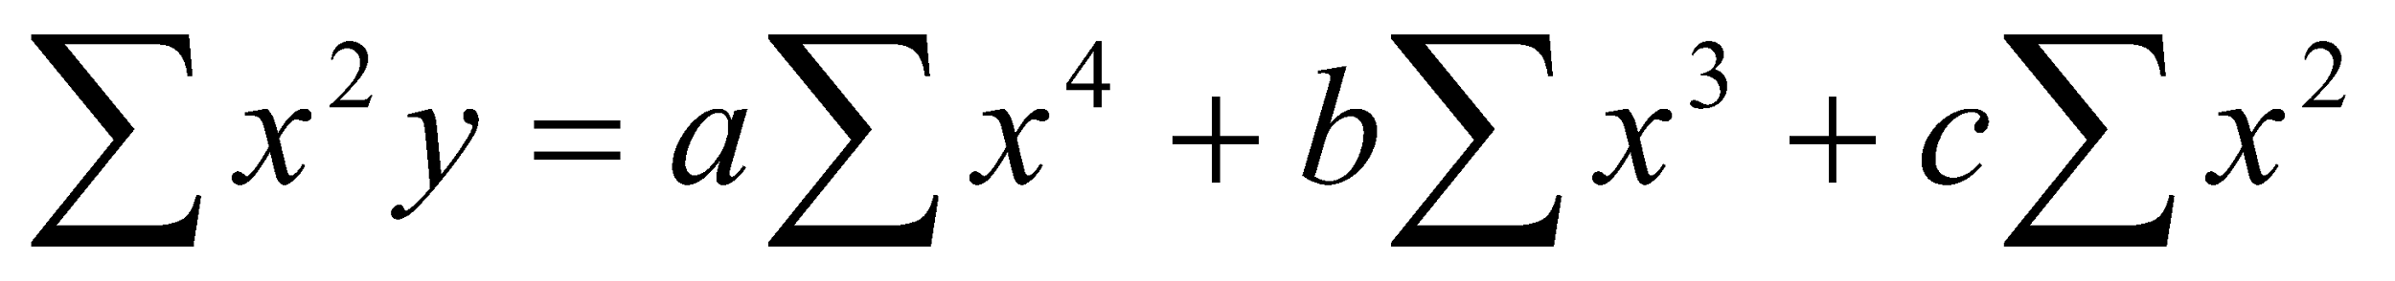 (c) 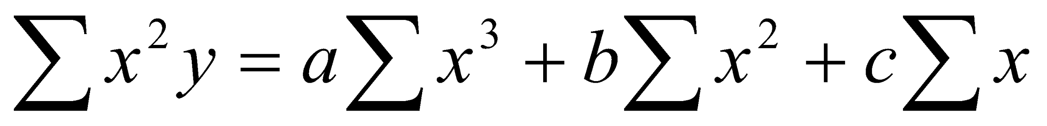 (d) 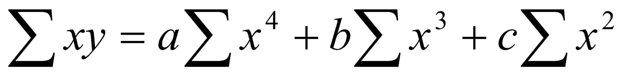
- By the method of least squares, the error committed in fitting a straight line is
(a) 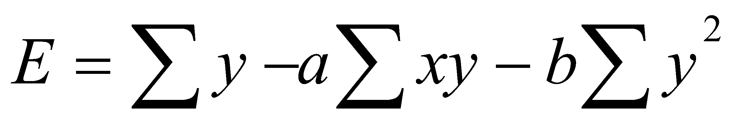 (b) 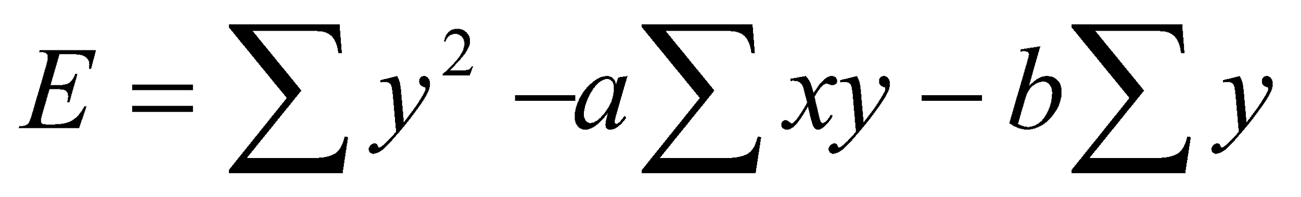
(c) 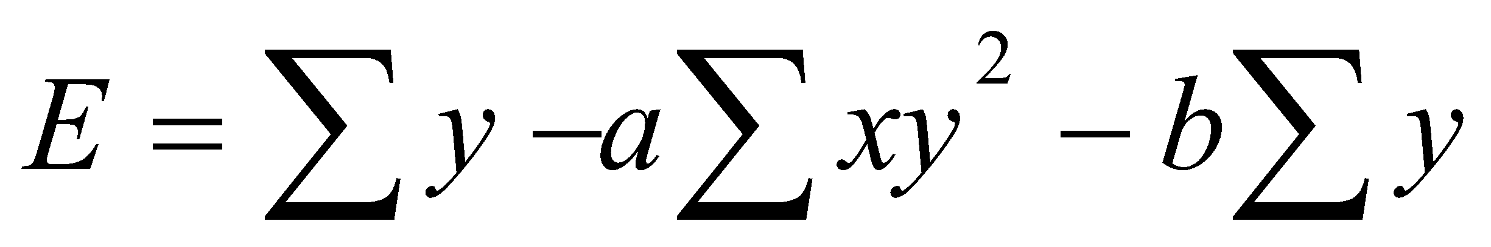 (d) 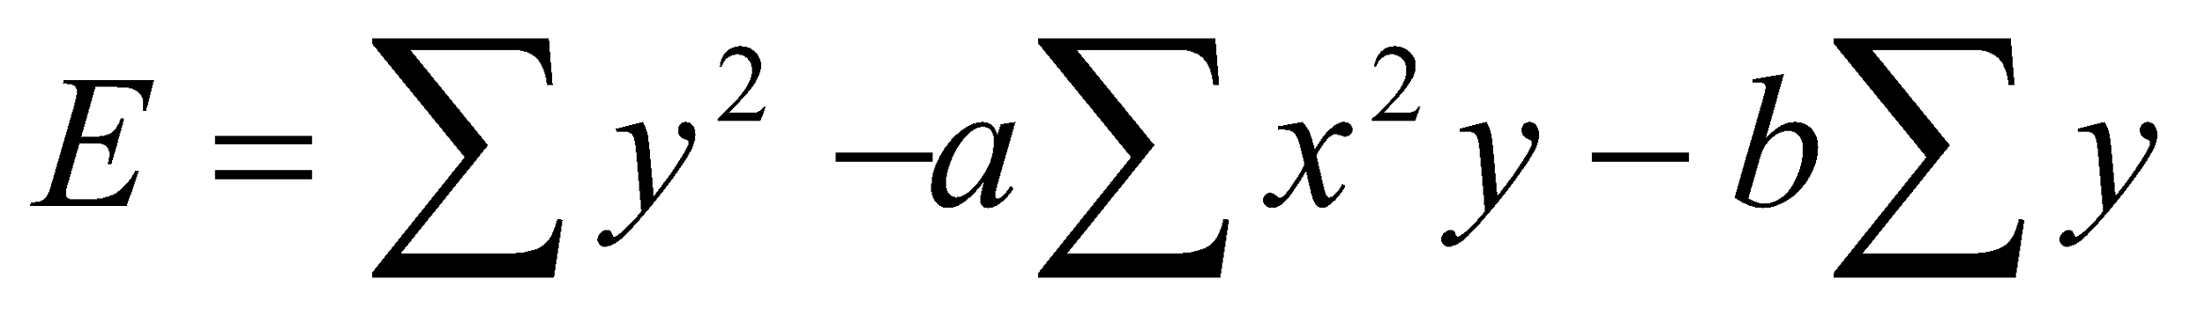
- The linear form of 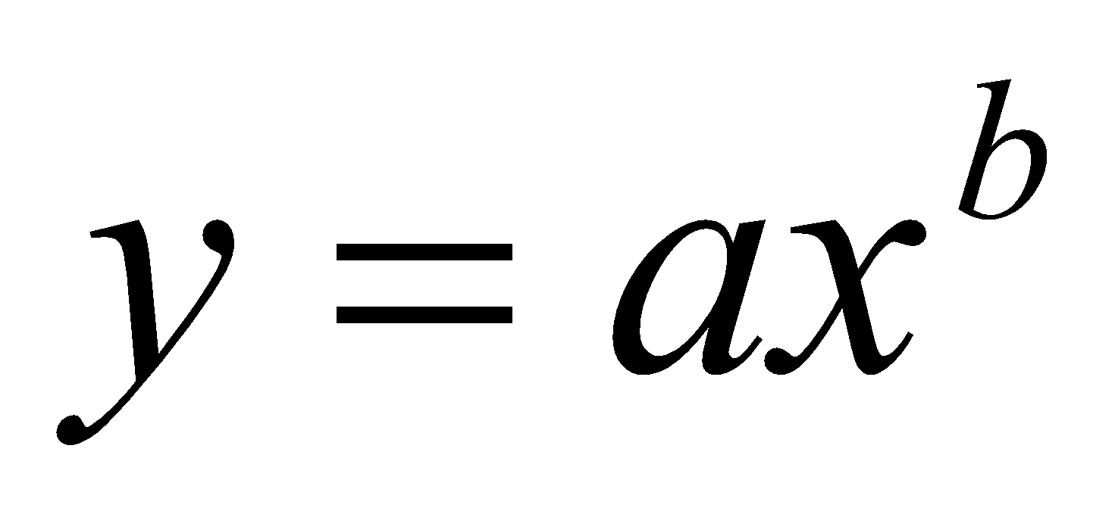is
(a) 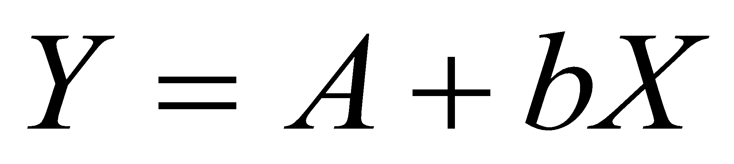 (b) 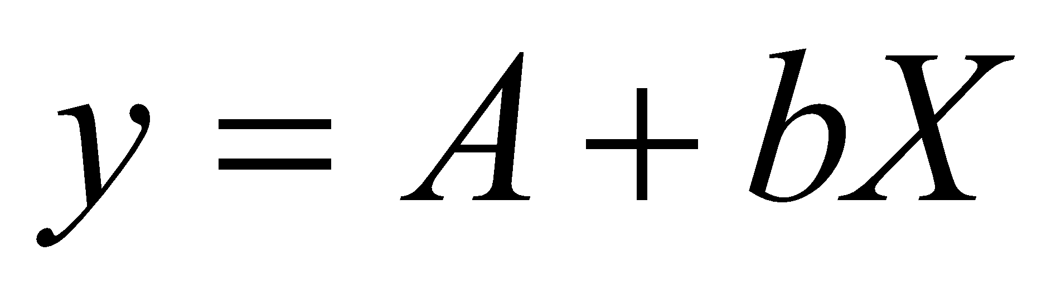 (c) 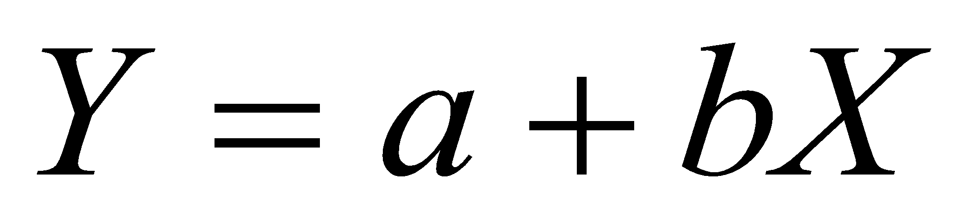 (d) 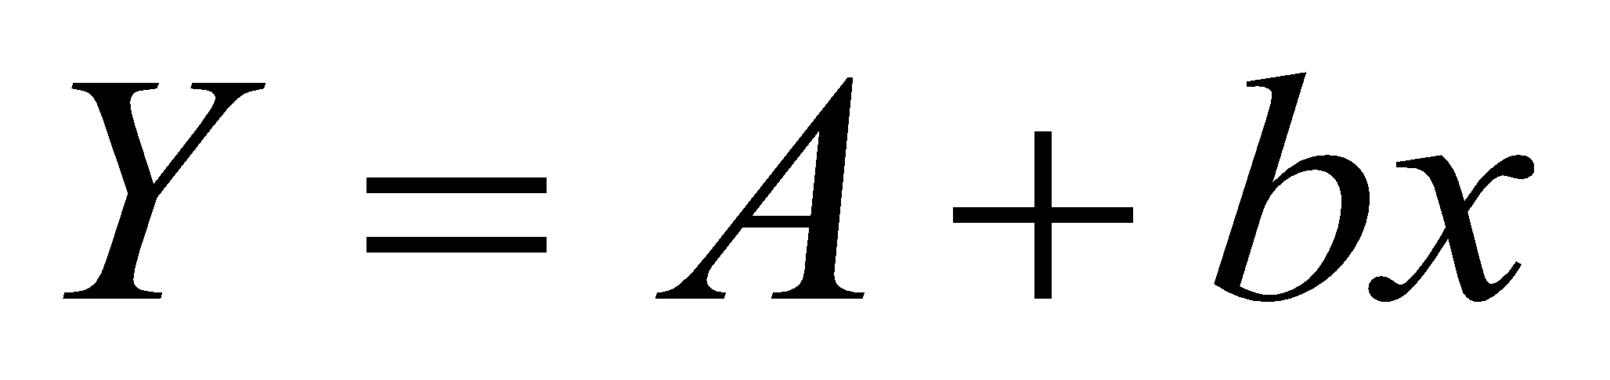
( capital letter indicates the logarithm of small letters)

ANSWERS
1. (c) argument
2. (b) entry
3. (a)
4. (d)
5. (a) Ef(x) = f(x+h)
6. (a) 1.f(x) = f(x)
7. (c)
8. (d)
9. (c)
10. (c)
11. (d) n
12. (d) A value of y nearer to the begining of the table of values
13. (c) Central value of the table
14. (a)
15. (c)
16. (a)
17. (d)
18. (a)
19. (d) Zeros
20. (d)
21. (b) Newton’s forward and backward formula is used
22. (d) constants
23. (a) Linear interpolation
24. (b) Parabolic interpolation
25. (d) Lagrange’s interpolation formula
26. (b) finding the values inside the interval
27. (a) finding the values outside the interval
28. (a) Minimum
29. (c) on the actual curve
30. (a) 
31. (b) 
32. (b) 
33. (a) 

